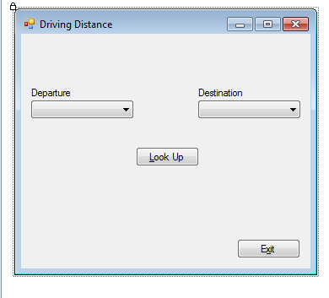

Fill the combo boxes with the city names by clicking on each box and entering them in the “Properties” section below:

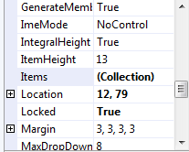

Imports System.IO

Public Class Form1

Private inf As StreamReader

Private city(10) As String

Private distance(10, 10) As Integer

Private Function data_upto_comma(ByRef x As String) As String

'This code retrieves data upto the 1st comma and also shrinks original string

Dim i As Integer = 0

Dim temp As String = ""

Dim y As String = x

Do While y.Substring(i, 1) <> ","

i += 1

Loop

temp = y.Substring(0, i)

'Strip out the data from string

x = y.Substring(temp.Length() + 1, y.Length() - temp.Length() - 1)

Return temp

End Function

Private Sub get_data_from_line(ByRef x As String, ByRef city As String, ByRef dist0 As Integer, _

ByRef dist1 As Integer, ByRef dist2 As Integer, ByRef dist3 As Integer, _

ByRef dist4 As Integer, ByRef dist5 As Integer, ByRef dist6 As Integer, _

ByRef dist7 As Integer, ByRef dist8 As Integer, ByRef dist9 As Integer)

city = data_upto_comma(x)

dist0 = Integer.Parse(data_upto_comma(x))

dist1 = Integer.Parse(data_upto_comma(x))

dist2 = Integer.Parse(data_upto_comma(x))

dist3 = Integer.Parse(data_upto_comma(x))

dist4 = Integer.Parse(data_upto_comma(x))

dist5 = Integer.Parse(data_upto_comma(x))

dist6 = Integer.Parse(data_upto_comma(x))

dist7 = Integer.Parse(data_upto_comma(x))

dist8 = Integer.Parse(data_upto_comma(x))

dist9 = Integer.Parse(x)

End Sub

Private Sub Form1_Load(ByVal sender As System.Object, ByVal e As System.EventArgs) Handles MyBase.Load

'Prompt user for input file name

If inf IsNot Nothing Then

inf.Close()

End If

'Open the file

Dim resp As DialogResult

resp = OpenFileDialog1.ShowDialog()

If resp <> DialogResult.Cancel Then

inf = New StreamReader(OpenFileDialog1.FileName)

Else

'user cancels

MessageBox.Show("no file to open; closing project")

Me.Close()

End If

'Read the data file

Dim i As Integer = 0

Dim line As String

'Read one line at a time

Do While inf.Peek <> -1

line = inf.ReadLine().ToString()

get_data_from_line(line, city(i), distance(i, 0), distance(i, 1), distance(i, 2), _

distance(i, 3), distance(i, 4), distance(i, 5), distance(i, 6), _

distance(i, 7), distance(i, 8), distance(i, 9))

i += 1

Loop

inf.Close()

End Sub

Private Sub Button1_Click(ByVal sender As System.Object, ByVal e As System.EventArgs) Handles Button1.Click

Dim departure As Integer

Dim destination As Integer

departure = ComboBox1.SelectedIndex

destination = ComboBox2.SelectedIndex

MessageBox.Show("Departure City is: " & city(departure).ToString & vbNewLine & _

"Destination City is: " & city(destination).ToString & vbNewLine & _

"Distance is: " & distance(departure, destination).ToString, _

MessageBoxButtons.OK, MessageBoxIcon.Information)

End Sub

Private Sub Button2_Click(ByVal sender As System.Object, ByVal e As System.EventArgs) Handles Button2.Click

Me.Close()

End Sub

End Class